F Y B Tech SEM I 2021-22

Engineering Physics Lab Course

**Experiment No.: 2**

**Title: Photoelectric Effect**

**Name : Hardik Shah**

**Roll No : 16010221025**

**Branch : ETRX**

**Batch : D2**

**Aim:**  To revise the concept of interference of light waves in general and thin-film interference in particular.

To set up and observe the Newton’s Rings.

To determine the wavelength of the given source.

**Apparatus:** A plano-convex lens of large radius of curvature, optical arrangement for Newton’s rings, plane glass plate, sodium lamp and travelling microscope.

**Diagram:**

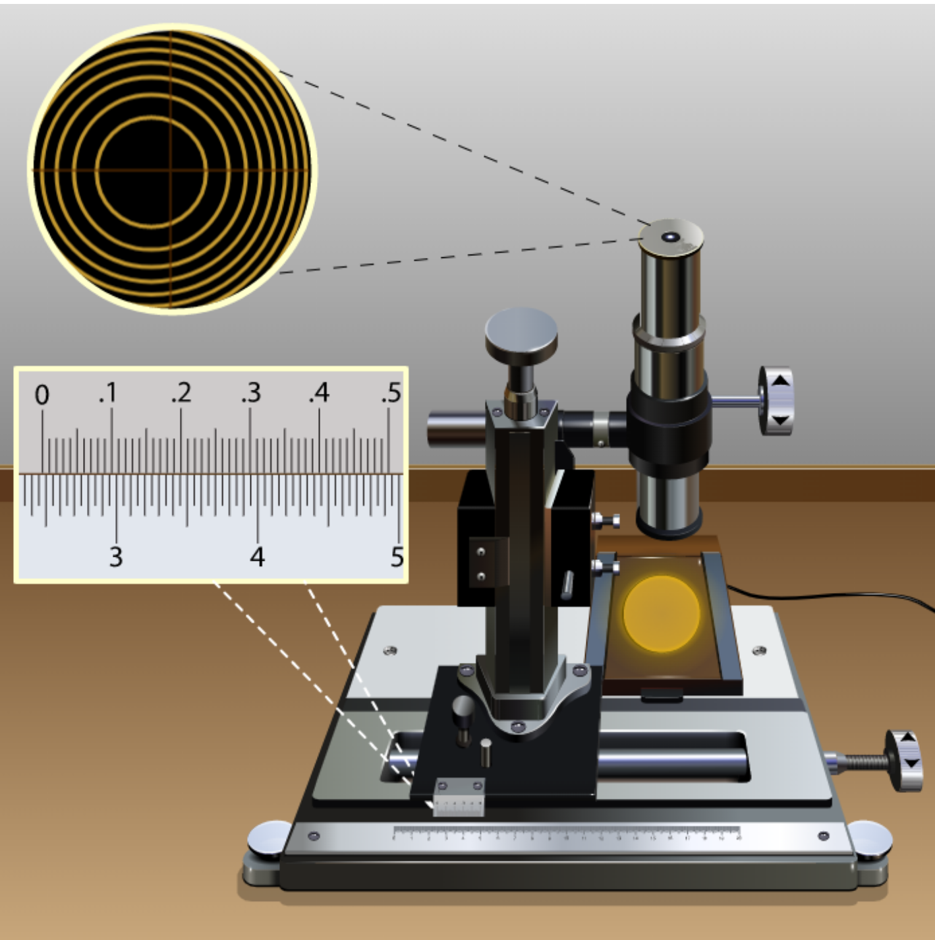

**Observation Table:**

|  |  |  |  |  |  |  |  |  |  |
| --- | --- | --- | --- | --- | --- | --- | --- | --- | --- |
| Sr. No. | n | Micro Meter Reading (cm) | | | | | | Dn (cm) | Dn2 (cm2) |
| L (on left side) | | | R (on right side) | | |
| MSR | VSR | TR | MSR | VSR | TR |
| 1 | 3 | 2.3 | 0.021 | 2.321 | 2.55 | 0.042 | 2.592 | 0.271 | 0.073441 |
| 2 | 4 | 2.3 | 0.004 | 2.304 | 2.6 | 0.013 | 2.613 | 0.309 | 0.095481 |
| 3 | 5 | 2.25 | 0.033 | 2.283 | 2.6 | 0.041 | 2.641 | 0.358 | 0.128164 |
| 4 | 6 | 2.25 | 0.013 | 2.263 | 2.6 | 0.036 | 2.636 | 0.373 | 0.139129 |
| 5 | 7 | 2.25 | 0.005 | 2.255 | 2.65 | 0.007 | 2.657 | 0.402 | 0.161604 |

**Graphs:**

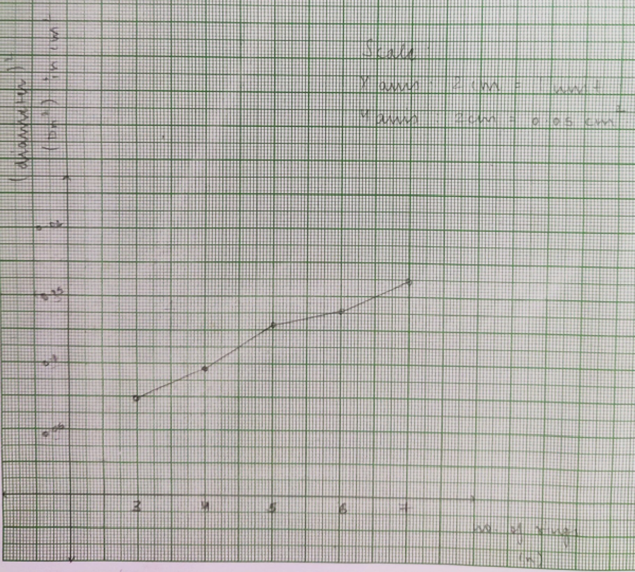

**Calculations:**

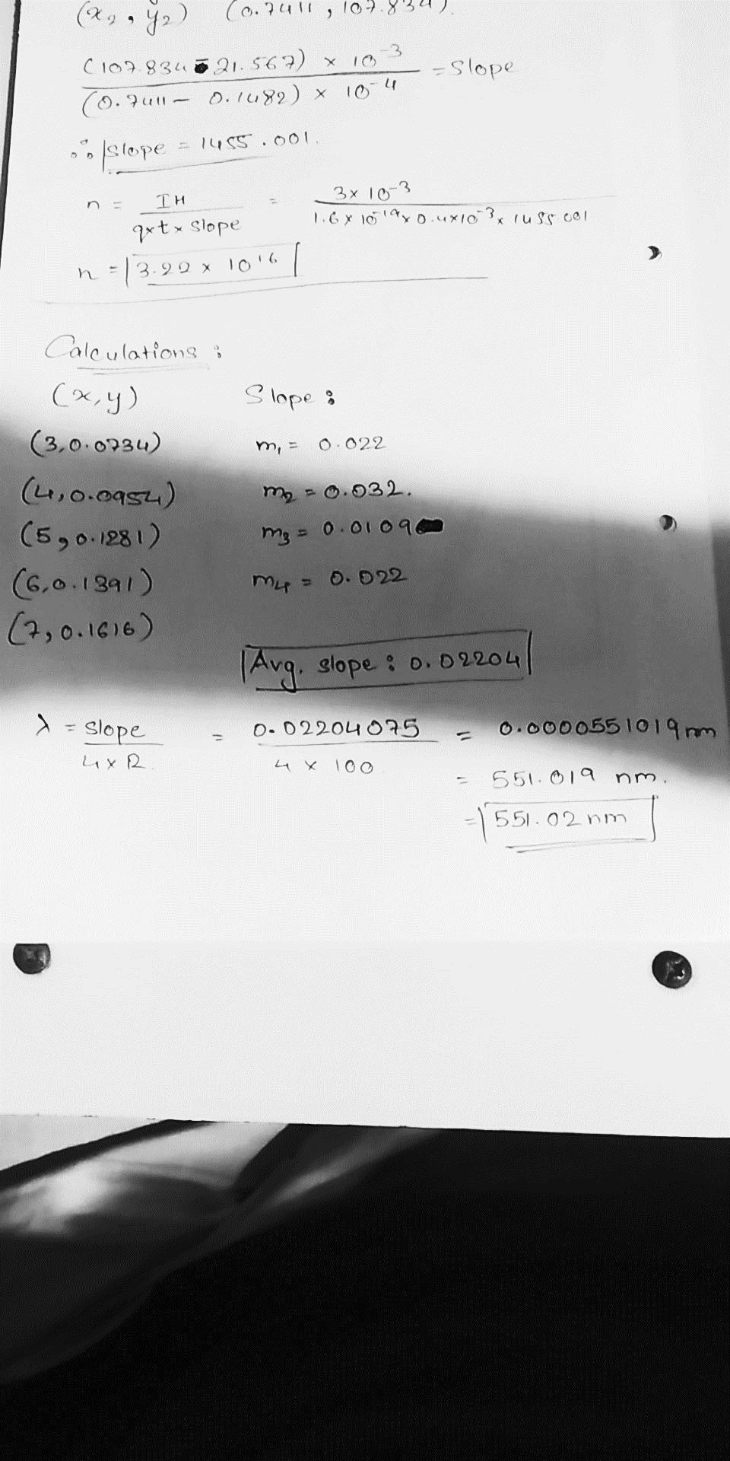

**Results:**  Wavelength of the given light is 551.02 nm.